Morocco

## Freedom House political status

The data set shows the Freedom House political scores and status of the country each year.

## # A tibble: 19 x 5  
## country iso3c date mean status   
## <chr> <chr> <dbl> <dbl> <chr>   
## 1 Morocco MAR 1996 5 Partly Free  
## 2 Morocco MAR 1998 4.5 Partly Free  
## 3 Morocco MAR 2000 4.5 Partly Free  
## 4 Morocco MAR 2002 5 Partly Free  
## 5 Morocco MAR 2003 5 Partly Free  
## 6 Morocco MAR 2004 4.5 Partly Free  
## 7 Morocco MAR 2005 4.5 Partly Free  
## 8 Morocco MAR 2006 4.5 Partly Free  
## 9 Morocco MAR 2007 4.5 Partly Free  
## 10 Morocco MAR 2008 4.5 Partly Free  
## 11 Morocco MAR 2009 4.5 Partly Free  
## 12 Morocco MAR 2010 4.5 Partly Free  
## 13 Morocco MAR 2011 4.5 Partly Free  
## 14 Morocco MAR 2012 4.5 Partly Free  
## 15 Morocco MAR 2013 4.5 Partly Free  
## 16 Morocco MAR 2014 4.5 Partly Free  
## 17 Morocco MAR 2015 4.5 Partly Free  
## 18 Morocco MAR 2016 4.5 Partly Free  
## 19 Morocco MAR 2017 5 Partly Free

## Freedom House classification of political change

The data set shows the GDP growth and the ecomic growth classification of the country each year.

## # A tibble: 19 x 4  
## country iso3c date politicalChangeFH  
## <chr> <chr> <dbl> <chr>   
## 1 Morocco MAR 1996 no change   
## 2 Morocco MAR 1998 democratization   
## 3 Morocco MAR 2000 no change   
## 4 Morocco MAR 2002 no change   
## 5 Morocco MAR 2003 no change   
## 6 Morocco MAR 2004 democratization   
## 7 Morocco MAR 2005 no change   
## 8 Morocco MAR 2006 no change   
## 9 Morocco MAR 2007 no change   
## 10 Morocco MAR 2008 no change   
## 11 Morocco MAR 2009 no change   
## 12 Morocco MAR 2010 no change   
## 13 Morocco MAR 2011 no change   
## 14 Morocco MAR 2012 no change   
## 15 Morocco MAR 2013 no change   
## 16 Morocco MAR 2014 no change   
## 17 Morocco MAR 2015 no change   
## 18 Morocco MAR 2016 no change   
## 19 Morocco MAR 2017 autocratization

## Freedom House score trend

The plot shows the Freedom House scores trend of the country.

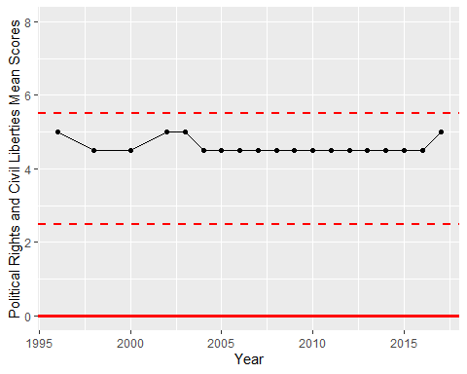

Freedom House Score Trend